FEDERAL UNIVERSITY OF TECHNOLOGY, MINNA
SCHOOL OF ELECTRICAL ENGINEERING AND TECHNOLOGY
DEPARTMENT OF ELECTRICAL AND ELECTRONICS ENGINEERING
EEE 511: INDUSTRIAL ELECTRONICS DESIGN



PROJECT REPORT OF THE DESIGN OF AN AUTOMATIC STREETLIGHT CONTROLLER

GROUP F

FEBRUARY 2026

- PROBLEM STATEMENT AND REQUIREMENTS
1.1 Problem statement
The manual operation of streetlight systems often leads to significant energy wastage when lights are left on during daylight hours, or safety hazards when they aren't turned on promptly at night.
Existing automated systems frequently suffer from:
- Fixed Thresholds: They cannot adapt to varying weather conditions and seasonal variations in daylight hours (like heavy overcast or storms).
- Lack of Flexibility: There is often no way to bypass the sensor for maintenance or emergency situations.
- Sensitivity Issues: Rapid flickering caused by momentary shadows or car headlights.
This project aims to design an automatic, reliable, adjustable controller that optimizes energy usage by responding to ambient light levels while providing manual control for maintenance.
1.2 Operating Environment
The controller will be installed in weatherproof enclosures mounted on streetlight poles or utility boxes. It must withstand temperature variations, humidity, dust, and occasional mechanical vibrations. The system requires protection against outdoor environmental conditions including rain, UV exposure, and electromagnetic interference from nearby power lines.
1.3 System Inputs & Outputs
1.3.1 Inputs
- Light Sensor: A Light Dependent Resistor (LDR) or a Photodiode to monitor ambient lux levels.
- Threshold Adjustment: A potentiometer (variable resistor) to allow the user to set the specific "darkness" level for activation.
- Manual Override: A 3-position physical toggle switch or push-button (Auto/Manual-ON/Manual-OFF).
1.3.2 Outputs
- Actuator: An electromagnetic Relay or Solid-State Relay (SSR) to switch the high-voltage AC lamp circuit.
- Status Indicators: LEDs to show system status (e.g., Green for "System Active," Red for "Lamp On").
1.3.3 Power Supply Assumptions
- Logic Level: 5V or 12V DC (via a step-down transformer and regulator).
- Load Level: 110V/220V AC mains for the actual street lamps.
1.4 Performance Requirements
Parameter | Requirement
Light Detection Range | 1 lux – 1000 lux
Threshold Adjustment | Threshold should be adjustable between 10 lux (deep dusk) and 100 lux (overcast day).
Response Time | ≤ 5 seconds switching delay after threshold detection with a 5–10 second delay (hysteresis) to prevent false triggering caused by lightning, car headlights or clouds.
Accuracy | ±10% light level measurement
Reliability | ≥ 50,000 hours continuous operation (approximately 5.7 years)  ≥ 100,000 switching cycles  Protection features;  - Reverse polarity protection  - Overvoltage protection  - Waterproof enclosure
Power consumption | < 5W (control circuit only, excluding light load)

- SYSTEM BLOCK DIAGRAM
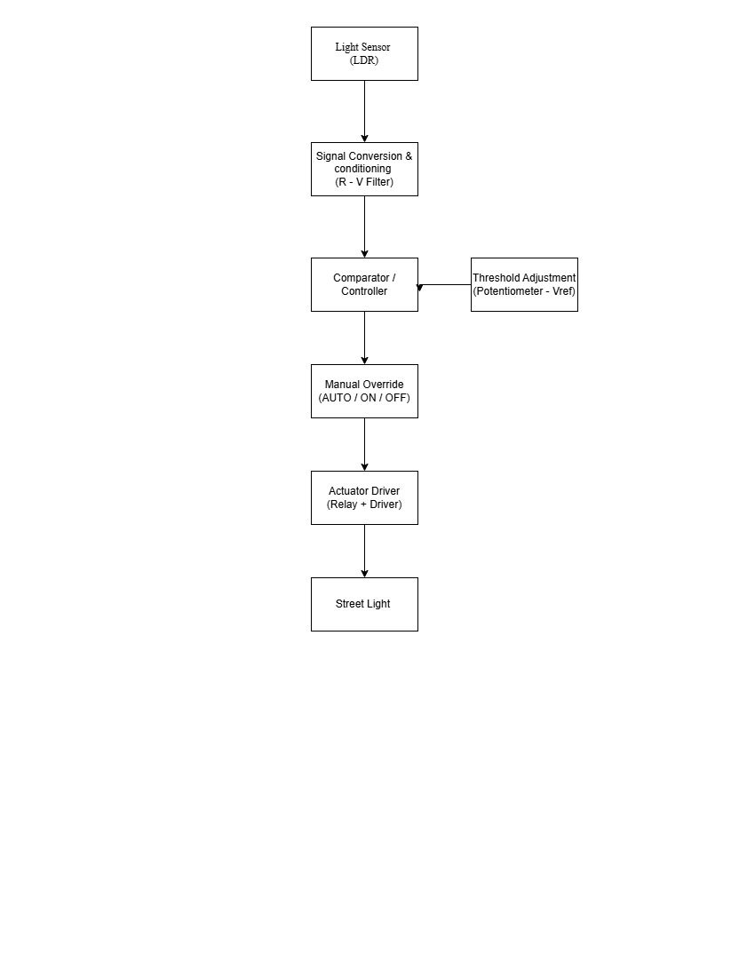

3.0 DESIGN CHOICES AND JUSTIFICATION
This section details the selection of hardware components and control logic for the streetlight controller. Each choice is made to ensure the system aligns with the specific performance requirements for reliability, environmental resilience, and energy optimization.
3.1.1 Transducer Selection: Light Dependent Resistor (LDR)
To monitor ambient lux levels within the required 1 lux to 1000 lux range, a Light Dependent Resistor (LDR) has been selected as the primary transducer.
- Sensitivity and Spectrum: LDRs are highly sensitive to visible light, making them ideal for detecting the transition between "deep dusk" (10 lux) and "overcast" conditions (100 lux).
- Cost-Efficiency: Compared to high-precision photodiodes, LDRs offer a cost-effective solution for widespread municipal deployment without sacrificing the necessary accuracy.
- Integration: The LDR integrates seamlessly with the R-V filter for signal conditioning, converting light intensity into a readable voltage level for the controller.
3.1.2 Switching Element: Electromechanical Relay
The system will utilize an Electromechanical Relay to interface between the low-voltage control logic and the high-voltage AC lamp circuit.
- Galvanic Isolation: A relay provides physical separation between the 5V/12V DC logic level and the 110V/220V AC load level, ensuring user safety during manual override or maintenance.
- Durability: The chosen relay meets the reliability requirement of 100,000 switching cycles, which is essential for a system designed for over 5 years of continuous operation.
- Thermal Management: Unlike semiconductors like SCRs, mechanical relays do not require extensive heat sinking to manage the streetlight load, allowing the controller to remain within the 5W power consumption limit.
3.1.3 Actuation Method: Relay Output
The actuation method is defined as a Relay Output configuration, where the controller drives the relay coil to open or close the lamp circuit.

- Application Suitability: While steppers or micromotors are used for mechanical positioning, a relay output is the industry standard for binary "ON/OFF" switching of electrical grids.
- System Indicators: This method allows for the simultaneous triggering of status LEDs (e.g., Red for "Lamp On") to provide clear visual feedback of the actuator state.

3.1.4 Controller Type: Microcontroller (MCU)
A Microcontroller is selected as the central "Comparator/Controller" unit.
- Hysteresis and Logic: An MCU is necessary to implement the required 5–10 second delay (hysteresis) to prevent false triggering or rapid flickering caused by momentary shadows or car headlights.
- Adjustable Thresholds: The MCU processes the analog input from the threshold adjustment potentiometer, allowing the user to set the activation point between 10 lux and 100 lux.
- Manual Override Integration: The MCU monitors the 3-position toggle switch (Auto/Manual-ON/Manual-OFF) to instantly bypass sensor logic for emergency or maintenance situations.

- PROTECTION, SAFETY, AND RELIABILITY
  - Protection and Fail-Safe Thinking
Designing a streetlight controller requires more than just making it work, it requires making it fail gracefully. In an outdoor or industrial environment, electrical spikes and environmental wear are certainties, not possibilities, therefore it is important to account for system failures. The following are common failure points;
- Overcurrent/Short Circuit: A fault in the high-voltage lamp or a wiring short that could melt the relay or start a fire.
- Voltage Surges: Lightning strikes or grid switching transients that can fry the sensitive 5V DC logic (microcontroller/LDR).
- Sensor Failure (LDR): If the LDR gets covered in bird droppings, dust, or physically breaks, the system might stay "ON" all day or "OFF" all night.
- Relay Contact Welding: High-inrush currents from LED drivers can "weld" the mechanical relay contacts together, making it impossible to turn the light off.
- Overheating: If the control box is in direct sunlight or the relay is overloaded, the internal temperature can exceed the operating range of the electronics.

4.1.1 Fault and Protection Table
Fault | Effect | Safe State | Protection
Overcurrent | Component failure / Fire hazard | Power shut off | Fuse (Glass or Ceramic)
Overvoltage | Voltage spike | Safe voltage clamped | TVS Diode / Varistor (MOV)
Overheating | Damage to internal circuit | Safe shutdown | Thermal Cut-off / Heat Sink
Sensor Failure | Unsafe reading (Permanent dark/light) | Output disabled (or forced ON) | Isolation / Logic Check
Wiring Fault | Short circuit / Electric shock | Immediate trip | Grounding / Enclosure Isolation
Environmental | Corrosion/Moisture | Sustained operation | IP66 Enclosure

4.1.2 Fail-Safe Operation
- Power Failure: The relay coil de-energizes. Depending on wiring (typically NO), the lights will turn OFF. Upon power restoration, the microcontroller/comparator re-evaluates ambient light and resumes the correct state within seconds.
- Sensor Failure (LDR Stuck Dark/Disconnected): High resistance or an open circuit mimics "night." The controller will hold the relay in the ON position. While this consumes energy, it ensures the street remains illuminated for safety. The operator can use the Manual Override to turn the lights OFF.
- Sensor Failure (LDR Shorted/Stuck Bright): The system "thinks" it is always noon. Lights remain OFF. The Manual Override allows the operator to force the lights ON for public safety until the sensor is replaced.
- Mechanical Relay Failure (Contact Welding): Occurs if high inrush current "melds" the metal contacts. The lights remain ON regardless of the sensor or control signal. In this specific case, the Manual Override may be ineffective if it shares the same power path; the main circuit breaker must be used for maintenance.
- Control Circuit/Microcontroller Failure: The relay coil loses power and returns to its "shelf state." If wired to the Normally Open (NO) contact, the lights stay OFF. However, the Manual Override (if wired as a physical bypass) allows emergency lighting without a functioning control board.
- Thermal Overload: If the internal temperature exceeds limits, a Thermal Cut-off (TCO) or thermal fuse interrupts the common power line to the relay coil or the load. The lights turn OFF to prevent a fire hazard. The system requires cooling and a manual inspection of the enclosure before reset.

4.2 Reliability Expectations
To ensure the controller is reliable for long-term street use, the design must address these pillars:
- Switching Longevity:
- Since streetlights switch twice a day, the mechanical relay must be rated for at least 100,000 cycles.
- Reliability Measure: Use a high-quality relay with a snubber circuit (RC network) to prevent contact pitting from AC arcs.
- Environmental Stability:
- The LDR sensor's sensitivity can drift with extreme temperature changes.
- Reliability Measure: Use a Schmidt Trigger circuit to ensure "clean" switching, preventing the light from flickering when the light level is exactly at the threshold.
- Operational Continuity (Manual Override):
- If the electronic "brain" fails, the system must still be serviceable.
- Reliability Measure: The Manual Override switch must be wired in parallel to the relay contacts. This ensures that even if the controller circuit dies, a technician can manually force the lights ON for public safety.
- Thermal Reliability (Heat Management)
- Electronic components age faster when exposed to high heat, especially inside a sealed outdoor box.
- Measure: Use temperature-stable resistors (metal film) and ensure the relay is rated for high-ambient temperature operation.
- Signal Reliability (Hysteresis & Debouncing)
- In a real-world environment, light levels don't drop instantly; they flicker due to clouds, shadows, or passing car headlights.
- Measure: Implementing Hysteresis (different turn-on and turn-off points) ensures the relay doesn't rapidly click on and off, which would burn out the contacts and the LED lamp.
- Mechanical & Environmental Reliability
- Since this is for a streetlight, it is exposed to humidity, rain, and dust.
- Reliability Measure: The enclosure must meet IP65 standards (dust-tight and water-jet protected), and the PCB should ideally be "conformal coated" to prevent moisture from shorting the high-impedance sensor traces.

- TEST PLAN (VALIDATION PLAN)
The following tests validate system functionality under normal and fault conditions. Each test includes pass/fail criteria and required measurement equipment.

# | Test Name | Procedure | Measurement | Pass/Fail Criteria
1 | Darkness Trigger | Gradually cover the LDR with an opaque material | Digital Multimeter (DMM) across Relay output. | Relay clicks and Load turns ON when LDR is dark.
2 | Daylight Cut-off | Expose the LDR to a bright light source (Flashlight/Sun). | Voltage at Relay Coil. | Relay clicks and Load turns OFF when LDR is illuminated.
3 | Threshold Range | Turn the Potentiometer to Min/Max and repeat Test 1. | Lux meter vs. activation point. | Trigger timing changes significantly based on knob position.
4 | Manual Override (ON) | Set 3-way switch to "Manual ON" during broad daylight. | Continuity or Load state. | Light turns ON immediately, bypassing all sensor logic.
5 | Manual Override (OFF) | Set 3-way switch to "Manual OFF" during pitch black. | Continuity or Load state. | Light turns OFF immediately, bypassing all sensor logic.
6 | Transient Shadow | Briefly pass a hand over the LDR (mimicking a bird flying over). | Stopwatch / Relay observation. | No switching occurs. The software delay ignores pulses < 5 seconds.
7 | Sensor Fault (Open) | Disconnect one wire from the LDR to simulate a broken lead. | Relay state observation. | System defaults to "Lights ON" (Fail-safe for public safety).
8 | Short Circuit Test | Briefly bridge the load side with a high-current load. | Physical fuse inspection. | The 5A fuse blows instantly, preventing damage to the relay.
9 | Thermal Resilience | Place the control box in a heat chamber or direct sun for 4 hours. | Internal thermometer/Probe. | Logic remains stable; enclosure shows no deformation or overheating.
10 | Hysteresis Recovery | Keep light level exactly at the threshold for 60 seconds. | Relay "chatter" (rapid clicking). | Relay switches ON once and stays ON; no rapid oscillations (chatter) allowed.

- BILL OF MATERIALS
This list covers the components needed for the controller and their prices.
Component | Description | Quantity | Price (₦)
Microcontroller | Arduino Nano | 1 | 8,500
Light Sensor | GL5528 LDR (Photoresistor) | 1 | 500
Threshold Adjustment | 10kΩ Linear Potentiometer + Knob | 1 | 1,200
Switching Element | 5V DC SPDT Relay Module (10A) | 1 | 2,500
Manual Override | 3-Position Toggle Switch | 1 | 3,500
Circuit Protection | Panel-mount Fuse Holder + 5A Fuse | 1 | 1,500
AC-DC Converter | Hi-Link 5V/1A Isolated Power Module | 1 | 6,500
Indicators | 5mm LEDs (Power & Status) | 2 | 400
Enclosure | IP66 Waterproof Plastic Junction Box | 1 | 2,000
Connectors | Terminal Blocks, Jumper Wires, Solder | 1 set | 4,000
Total |  |  | ₦30,600

